**TABLE DESIGN**

**TABLE NO: 1 TABLE: login**

|  |  |  |  |
| --- | --- | --- | --- |
| **Field** | **Datatype** | **Constraint** | **Description** |
| logid | Number(10) | Primary Key | To store the id |
| Username | Varchar(10) | Not null | To store the username |
| Password | Varchar(10) | Not null | To store the password |

**TABLE NO: 2 TABLE: category**

|  |  |  |  |
| --- | --- | --- | --- |
| **Field** | **Datatype** | **Constraint** | **Description** |
| Sub_catid | Int(20) | Primary Key | To store the id |
| Sub_catName | Varchar(10) | Not null | To store the username |

**TABLE NO: 3 TABLE: registration**

|  |  |  |  |
| --- | --- | --- | --- |
| **Field** | **Datatype** | **Constraint** | **Description** |
| regid | Int(10) | Primary Key | Id of  tbl_registration |
| logid | Number(10) | Foreign Key | logid from tbl_login |
| Username | Varchar(10) | Not null | To store the username |
| Password | Varchar(10) | Not null | To store the password |
| Confirm Password | Varchar(10) | Not null | To store the  Confirm Password |
| Address | Varchar(10) | Not null | To store the Address |

**TABLE NO: 4 TABLE:item**

|  |  |  |  |
| --- | --- | --- | --- |
| **Field** | **Datatype** | **Constraint** | **Description** |
| Item_id | Int(20) | Primary Key | To store the itemid |
| ItemtName | Varchar(10) | Not null | To store the itemname |
| Sub_catid | Varchar(10) | Foreign Key | Reference from tbl_category |
| Price | Number(10) | Not null | To store price |

**TABLE NO: 5 TABLE: payment**

|  |  |  |  |
| --- | --- | --- | --- |
| **Field** | **Datatype** | **Constraint** | **Description** |
| Payment_id | Varchar(10) | Primary key | to store payment id |
| Item_id | Int(10) | Foreign key | To store subcategory (Reference from tbl_item ) |
| Name | Varchar (10) | Not null | Name on card |
| Bank name | Varchar (10) | Not null | Bank name |
| Card number | Varchar (10) | Not null | Card number |
| Exp-date | Date | Not null | Expiry date |
| Cvv no | Varchar (10) | Not null | Cvv number |

**Table 6:feedback**

|  |  |  |  |
| --- | --- | --- | --- |
| **Field** | **Data type** | **Constraint** | **Description** |
| fid | Int | Primary key | It is store the feedback id |
| Logid | int | Foreign key | It store the login id |
| Username | Varchar | Not null | It store the username |
| Feedback | Varchar | Not null | It strore the feedback |

|  |  |  |  |
| --- | --- | --- | --- |
| **Field** | **Data type** | **Constraint** | **Description** |
| Orderid | Int | Primary key | Order id |
| Logid | Int | Foreign key | login id |
| Itemid | Int | Foreign key | Item id |
| Quantity | Int | Not null | Quantity |
| Price | int | Not null | price |
| Date | Date | Not null | Date |

**Table 7:Order**

**Table 8:add to cart**

|  |  |  |  |
| --- | --- | --- | --- |
| **Field** | **Data type** | **Constraint** | **Description** |
| Cartid | int | Primary key | Order id |
| Logid | int | Foreign key | login id |
| orderid | int | Foreign key | Item id |
| Quantity | int | Not null | Quantity |
| Price | int | Not null | price |

1. **Use case Diagram**

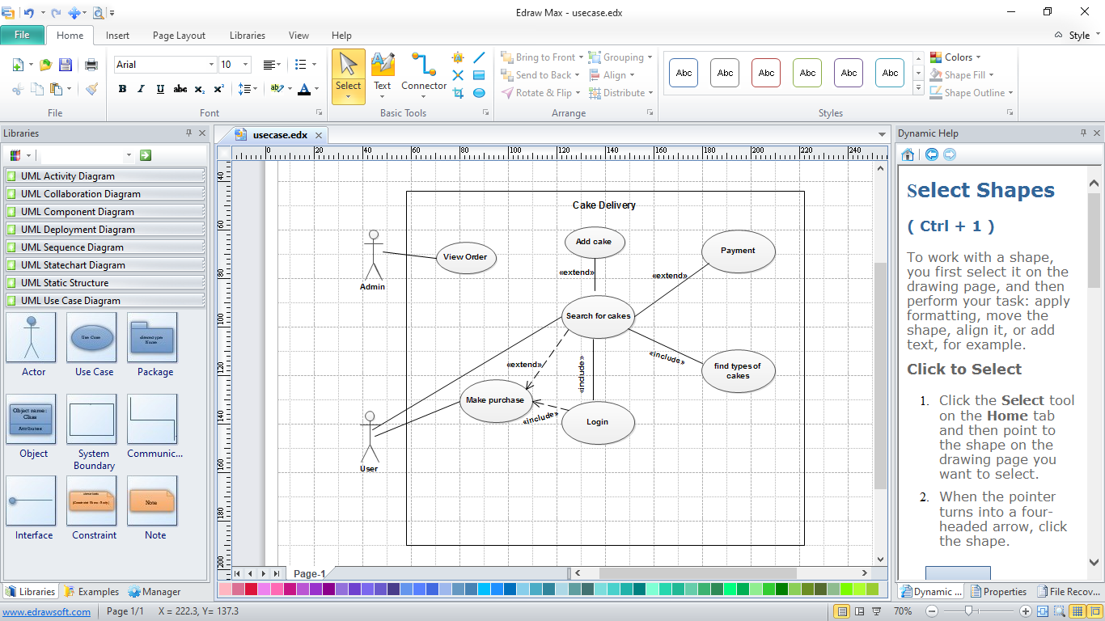

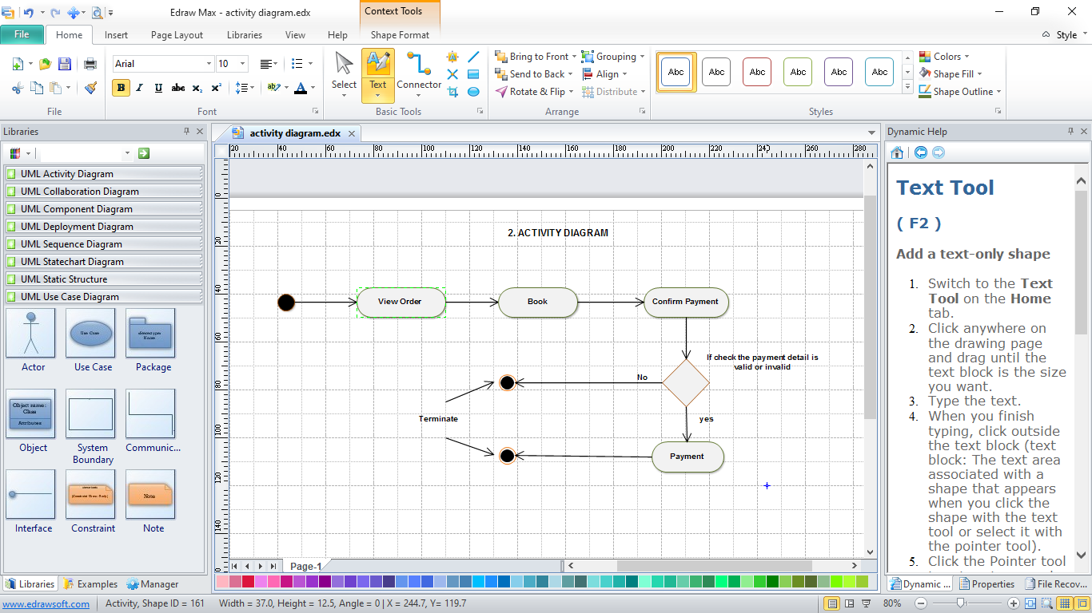

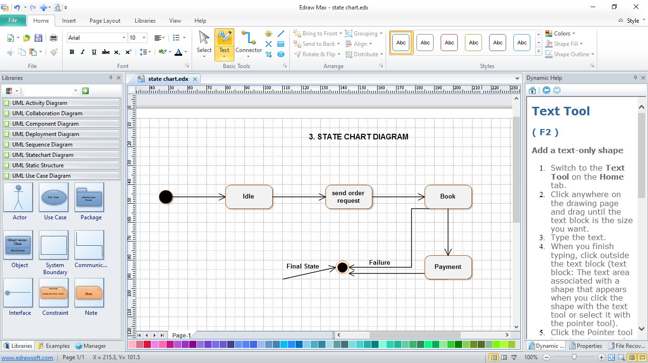

**4.Sequence Diagram**

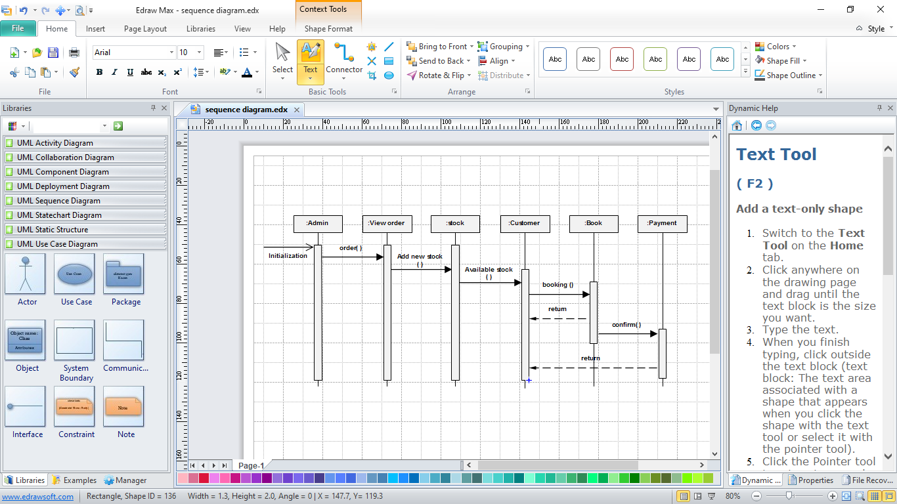

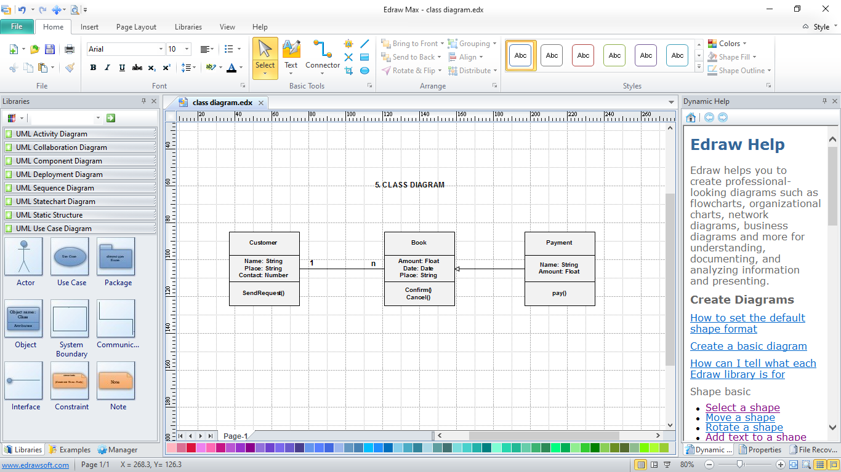

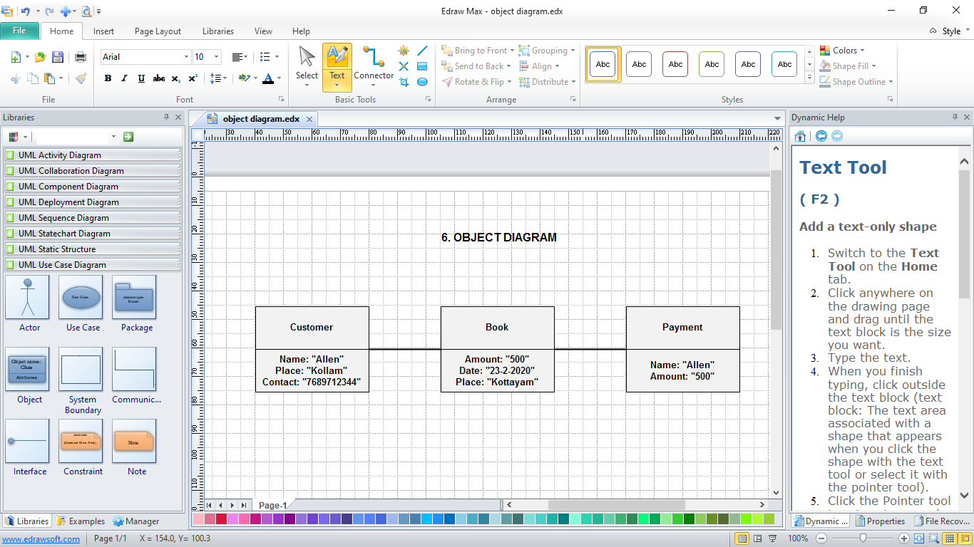

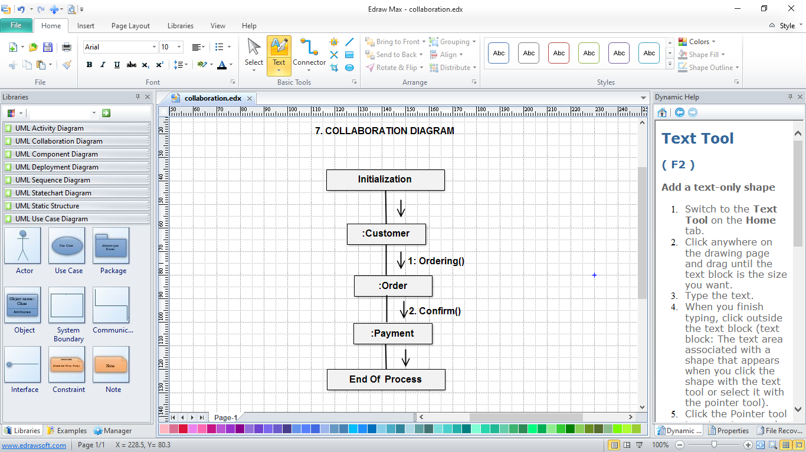

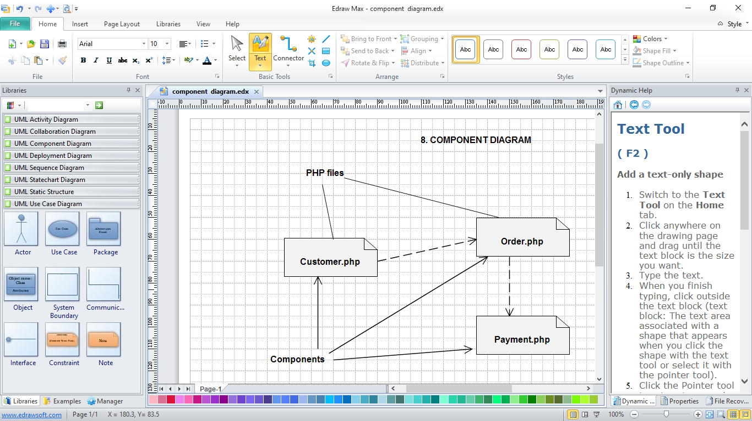

**9.Deployment Diagram**

